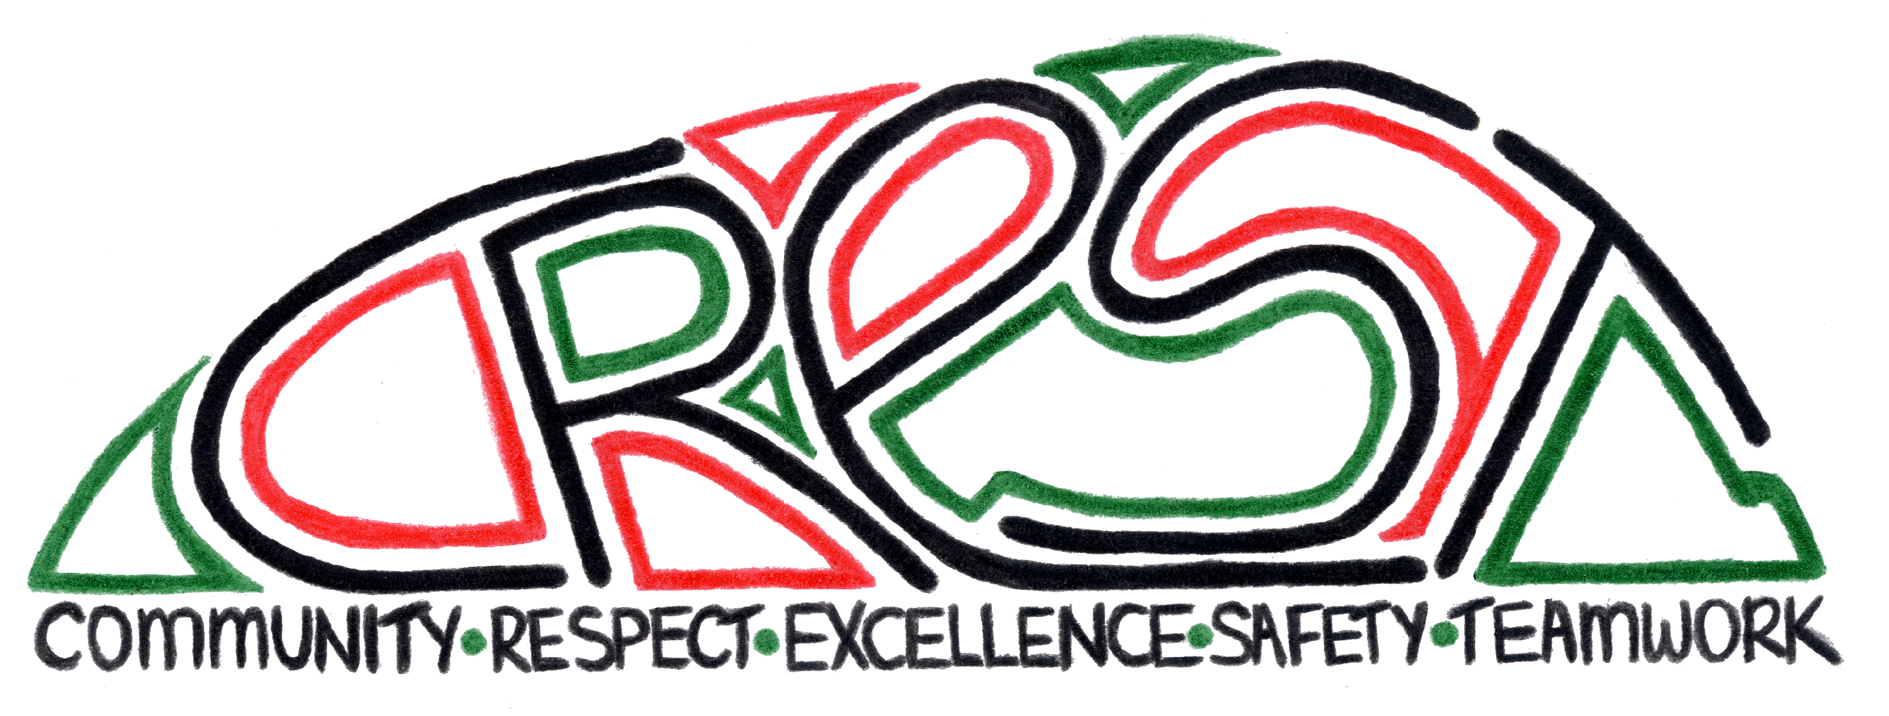
STUDENT WELLBEING
Duval
Community
Duval High School
NSW Department of Education and Communities
BEHAVIOUR CODE FOR STUDENTS - SAFETY

- Model and follow departmental, school and class codes of behaviour and conduct
- Negotiate and resolve conflict with empathy
- Take personal responsibility for behaviour and actions
- Care for self and others
- Avoid dangerous behaviour and encourage others to avoid dangerous behaviour

NSW Department of Education and Communities
BEHAVIOUR CODE FOR STUDENTS – RESPECT
- Treat one another with dignity
- Speak and behave courteously
- Co-operate with others
- Develop positive and respectful relationships and think about the effect on relationships before acting
- Value the interests, ability and culture of others
- Dress appropriately by complying with the school uniform or dress code
- Take care with property

ATTENDANCE:
Students are required to:
- Attend school every day (unless legally excused)
- Arrive at school and class on time
- Be prepared for every lesson
- Actively participate in learning
- Aspire and strive to achieve the highest standards of learning

The principal and school staff, using their professional judgment, are best placed to maintain discipline and provide safe, supportive and responsive learning environments. The department provides a policy framework and resources such as Legal Issues Bulletins, access to specialist advice and professional learning to guide principals and their staff in exercising their professional judgment. In this context the NSW Government and the Department of Education and Communities will back the authority and judgment of principals and school staff at the local level.

Students are required to attend every lesson. If a student is absent from a class without a satisfactory reason, the student will be marked as having truanted that lesson, and will be either placed on a Truancy Card and/or have a truancy letter sent home. Students on a truancy card must present this to both their classroom teacher each lesson, and to the teachers on playground duty at recess and lunchtime for four successful days.

Continued truancy will be dealt with through the discipline system, and if persistent will be reported to the Home School Liaison Officer for management.

The following principles have guided the development of the discipline system. Respect for people and property by demonstrating:
- The right to learn in a rewarding environment
- Tolerance, consideration and understanding of others
- Self-development
- Encouragement and recognising achievement
- Fairness and consistent application of the penalties for serious misbehaviour

OUR MISSION IS TO CREATE A CARING, SAFE AND SUPPORTIVE SCHOOL ENVIRONMENT WHERE ALL STUDENTS CAN LEARN. WE ARE A PROUD POSITIVE BEHAVIOUR FOR LEARNING (PBL) SCHOOL.

THE RIGHTS OF STUDENTS
The provision of a safe, happy and positive learning environment is a key focus for all government schools and for Duval High School in particular.
Duval High School prides itself on being able to provide such an environment and has a long tradition of care.
Duval High School also emphasises that it is the right of all students to be able to learn without disruption from others, to be free from harassment and bullying and to feel safe from conflict in the school grounds and classrooms.

STUDENT RESPONSIBILITIES
All students are responsible for the following behaviour and values
- Acceptance and understanding of others
- Courtesy, consideration, co-operation and common sense
- Commitment to excellence in student achievement
- Diligence and sustained effort in class and in class assignments
- Compliance with school rules, directions and guidelines
- Regular attendance at school and classes
THE WEB OF STUDENT WELLBEING
It is the vision of Duval High School to create a climate of care. Our students have access to support, guidance and counselling from the following staff:
- The Principal, Deputy Principal, Wellbeing Co-ordinator/Anti-Harassment Officer, School Counsellor, Aboriginal Education Officer and Year Advisers

- Learning Support Teacher, Anti-Racism Officer, Boys’ Supervisor, Girls’ Supervisor

- Head Teachers, Subject Teachers, Careers Adviser, School to Work Co-ordinator and Sports Coaches

- Peer Support Mentors

- Student Representative Council Members

CLASSROOM CODE OF BEHAVIOUR
All students have the right to learn without disruption or distraction from others.
The following PBL rules are displayed in all classrooms in the school:
The Five Classroom Expectations
- Be prepared to learn, be equipped to learn

- Respect self, others and property

- Focus on learning, use devices as instructed

- Follow instructions and classroom procedures

- Hands up, listen

DUVAL HIGH SCHOOL’S AWARD SYSTEM

E-CREST Awards

E-Crests are given by teachers for doing what should be done in all areas of the school. E-CRESTs are part of our PBL initiatives to encourage positive behaviour in our students. When students receive an e-crest, they need to register it electronically by swiping it in the library, or by scanning the e-crest with a smart phone.

10 e-CRESTS will earn one Commendation in the school’s award system.

COMMENDATIONS

COMMENDATIONS are for:
- Community participation
- Personal bests
- An exceptional piece of work
- Performing above the expected standard

These Commendations are registered electronically by the student, and are used to determine if a student is eligible for one of Duval High School’s Student Awards.

The Award System is structured as follows:

Starting in Year 7, a student begins on a neutral level, then commendations are added to achieve the following levels:

- BRONZE AWARD 5 Commendations from at least 2 core values.
- SILVER AWARD 10 additional Commendations from at least 4 core values.
- GOLD AWARD 15 additional Commendations.
- DUVAL HIGH SCHOOL JUNIOR AWARD OF ACHIEVEMENT
Another 20 Commendations.

THE NEW SENIOR AWARD SYSTEM

Year 11 students start the year at zero, and then earn two main awards until the end of their year 12 studies:

- AWARD OF ACHIEVEMENT
(10 Commendations)

- AWARD OF EXCELLENCE
(Another 10 Commendations, 20 in total).

- SENIOR CREST AWARD:
This is a stand-alone award that will be issue even if not complete, but is a requirement for the Award of Excellence.
The award has the core values on it and students are required to demonstrate how they have achieved these core values, record the actions and ask a relevant teacher to sign that it has been achieved. This award will be valuable for scholarship, college and job applications as they will be evidence of the student’s demonstration of values pertaining to their future studies and careers.

DUVAL HIGH SCHOOL’S PBL CORE VALUES:

- COMMUNITY
- RESPECT
- EXCELLENCE
- SAFETY
- TEAMWORK

CLASSROOM TEACHER REFERRAL AND RESTITUTION
(Green Plan)

1. A student who has demonstrated behaviour below the teacher expectation will be directed to the time out desk in the classroom. The student will be directed to complete a green form outlining the unacceptable behaviour that has been demonstrated in class. The student will be directed to make an appointment with the teacher within 4 school days to address the teacher’s concerns.

The student is to approach the teacher for a meeting at recess or lunch to discuss the issues. Part of the discussion will involve the student and the teacher working on a plan to ensure that the student has the opportunity to rectify the behaviour or behaviours.
The student’s behaviour will be monitored for a period of 2 weeks (1 cycle of lessons): If the behaviour is satisfactory, the student will continue to work in class monitored by the teacher in the same way as the rest of their cohort.
2. A student who breaks their plan, or who refuses the placement at the timeout desk will be referred to the Head Teacher of that faculty, and directed by the Head Teacher to complete a Red Plan.

This system works similarly in:

- the playground
- sport and sport detention
- religion classes
- excursions
- roll call

The placement of a student on the classroom teacher referral sheets is at the discretion of that teacher. Once the process has been enacted a student must take the responsibility to make restitution with the teacher and plan for their educational and social outcomes.

Likewise, this process is repeated for the Head Teacher (Red) Plan.
EXECUTIVE/HEAD TEACHER PLAN
(Red Plan)

REASONS FOR BEING PLACED ON A RED PLAN
A student who has refused, or not undergone the appropriate restitution with the classroom teacher will be referred to the relevant Head Teacher. Other reasons may also include:
- Continued disruptive behaviour in class
- Continued Truancy
- Disobedience
- Rudeness
- Harassment/Bullying
- Cyber-bullying*
- Verbal abuse
- Misrepresentation e.g. lying, rumour-mongering

WHEN A STUDENT IS PLACED ON A RED PLAN
A student who is placed on a Red Plan will:
- Be monitored for two weeks
- Have a Parent Notification Letter sent home;
- Be advised of the consequences of further misbehaviour
This is at the discretion of the Head Teacher.
*Cyber-bullying includes:
- Sending harassing or threatening emails or text messages
- Making repeated phone calls to other students or teachers
- Posting information about, or photographs of, a person on web pages

EXCURSION LICENCE

- Every student at Duval High School is allocated 10 Excursion Licence points at the start of each year.
- When students are placed on a Green or Red Plan, or if they are suspended or given other consequences, points will be deducted from their Excursion Licence.
- Students on zero points cannot attend non-compulsory excursions.
- Students redeem points at the rate of 2 points per 10 school days, unless other offences occur.
SUSPENSION

Suspension occurs when a student is refused entry to the school as a result of his/her behaviour or actions. The student on suspension is placed in the care of parents/caregivers and may not return to school until the situation is resolved and the safety of students is ensured.
- Parents are required to supervise their student during the period of suspension.
- Parents will also be required to attend a re-entry interview with the Principal as part of the resolution process.

REASONS FOR BEING PLACED ON SUSPENSION

While incidents requiring suspension are rare at Duval High School, the Department of Education and Communities has emphasised that all parents should be advised that the following behaviours are totally unacceptable in our school and that students involved may be placed on suspension:
- Violence or threats of violence (including gestures), repeated harassment, bullying and/or victimisation (including cyber-bullying)
- Persistent disobedience, including persistent truancy, serious and/or persistent rudeness or insolence to a teacher and refusal to comply with reasonable requests or instructions
- Dangerous behaviour, damaging property and vandalism
- Possession or use of prohibited items, including weapons and drugs
- Involvement in criminal behaviour related to school, including the misuse of mobile phones and/or technology, such as computers, and theft

Prohibited items at school include aerosol sprays, lighters, matches, cigarettes, e-cigarettes, illegal and prescription drugs, weapons and home-made items which could be used as weapons. Prohibited items will be confiscated and returned to the student or the parent, as appropriate. Cameras and camera phones which are used to take photographs on school premises will also be confiscated and returned to parent/ carers when deemed appropriate by the school.

WHEN A STUDENT IS PLACED ON SUSPENSION

- Suspension from all school activities for a short term or long term. Suspension will be made by the Principal or Deputy Principal in line with Departmental Guidelines on Suspension and Expulsion.

- A visit to the School Counsellor may be required for students who return from suspension.

- No student is to return to school from suspension until an interview has occurred with the Principal or Deputy Principal and Parents/Guardians. The terms of re-entry for the suspended student are negotiated at this interview.

- Students on long suspension may be offered a place at the Karayuna Learning Centre, based at Drummond Primary School. It offers a supportive and structured environment in which students develop skills to help them re-engage on their return to school and to continue with studies.

STUDENTS EXPERIENCING BULLYING, HARASSMENT OR RACISM

Our current Anti-Bullying Policy is available from the school office or please refer to the Duval High School website.

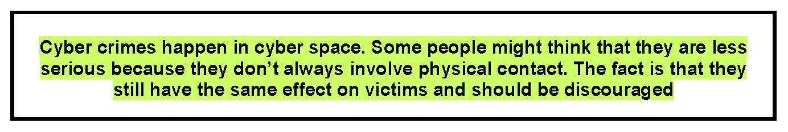
DUVAL HIGH SCHOOL STUDENTS AND CYBER CRIME
What is Cyber Crime?
Cyber Crime occurs when communication technologies, such as phones and computers, are used to commit traditional crimes such as stalking, intimidation, fraud, false/misleading information and malicious acts.
Electronic communication allows anonymity and distance between the offender and the target. Some people may be less inhibited and more willing to engage in anti-social or criminal behaviour when they don’t have to be physically present.
Cyber Crime is an increasing concern, as young people tend to spend hours on the internet or the phone after school hours. While this gives them access to greater knowledge and a larger world, they may also be at risk of the following:

- receiving unwanted communications,
- being a target of crime, or
- engaging in criminal behaviours.

How does Cyber Crime relate to school?
Issues that develop at school between people may continue after school hours. In some cases, students have continued the conflict or issue by email, text messaging, websites or chat rooms. This exacerbates the situation at school.
A student may not realise that they are committing a crime but think they are just continuing a conflict or having fun.
The crime of intimidation occurs when a student:
- sends harassing emails or text messages
- makes repeated phone calls to other students or teachers
- posts information about a person on web pages that is false or misleading or defamatory.
The crime of stalking occurs when a student follows other students or teachers on the internet to different chat rooms, usually to prevent them from communicating freely. Stalking does not require the offender to be physically present at the same location as the target. Students need to know that they are breaking the law when they engage in such behaviours. The offences of stalking or intimidation may have been committed if the accused has committed an act falling within one or both of the above definitions, with the intention of causing another person to fear physical or mental harm. An AVO may be granted to prevent this behaviour. Section 562AB of the Crimes Act

What can schools do about students engaging in Cyber Crimes after school hours?

Schools can intervene to stop incidents between students and other students or teachers that occur after school hours, if the incident has arisen out of the school relationship.

It must be clear that the incident occurred because the offender was a student at the school and the victim was a student or teacher at the school. The school discipline code can be applied and suspension may be used. According to the guidelines for short suspension 6.2.1 aggressive behaviour includes threatening abuse transmitted electronically or by SMS.
Cyber laws
Parts of the Commonwealth Crimes Act 1914 regarding offences involving misuse of telephone services have been repealed and updated to reflect modern technologies. The relevant sections are quoted below.

Information provided by the Department of Education and Communities Legal Services.

DUVAL HIGH SCHOOL POLICY:
STUDENTS ENGAGING IN CRIMINAL ACTIVITY

The Deputy Director-General (Schools) has directed all principals of secondary age students to advise both students and parents, in writing, of the procedures to be followed in cases where students are engaging in criminal activity. Year meetings with students will also be held to ensure that students are aware of these procedures and understand the consequences which will result from such behaviours. This particularly refers to the following activities:
- Making threats to harm other people, including threats made over the internet, or on phones or through SMS
- Sending harassing or menacing SMS or email messages
- Threatening, in practice, or through technology, teachers/students with a weapon, home-made weapon or fake gun
- Filming assaults using mobile phones and sending the film to others, sharing with others or publishing it on the internet
- Bringing weapons, home-made weapons, or fake guns to school

Message to students
- All schools have discipline policies that ensure members of the school community behave responsibly and are treated with respect.
- Students are commended for showing genuine concern for the welfare of their friends and others. Students who share information with staff allows help to be provided to peers who are involved in, or considering, criminal behaviour.
- Students have often played a key role in preventing crimes and their consequences.
- Unacceptable behaviour can have significant consequences. It is important you are aware of these consequences.
- If students use the internet, emails or mobile phones in a way that is offensive, harassing or menacing, this is a serious crime with heavy penalties, including imprisonment.
- If students use mobile phones to film criminal behaviour that they or their friends are engaged in, and then share the film with other people or post it on the internet, it is itself a criminal offence.
- If a student witnesses a crime and records images of a crime on a mobile phone or cameras they should give it to the police as soon as possible.
- Having a gun, including a fake gun that looks real, is a serious crime with heavy penalties.

- Having, without a good reason, knives, or other items that can be used as weapons, is also illegal.
- Being present as part of a group while a crime is being committed by others in the group can lead to all of those present being charged, even when some of those in the group did not engage in the specific act of the crime.
- Students can be held responsible and punished for a crime, even when the intention of the offence is not criminal (e.g. pranks, jokes).
- Pranks, particularly if they involve the use of fake weapons, can be very serious in ways that the student may not intend. If another person believes that the weapon is real, they could suffer serious harm, such as a heart attack, and you could be punished as a criminal.
- If a student is found guilty of a serious criminal offence it could have a big effect on future life – it could affect work prospects, or restrict the right to travel to some places.
- All students must report to the principal, teachers, the police or other responsible adults, any criminal behaviour that they see, or that they know is being planned by others. Students should not see reporting a crime as “dobbing in a mate” – such action may in fact save someone’s life or prevent serious injury or damage from occurring.
- Principals should also ensure that any incidents of a serious criminal nature are reported to the Department’s School Safety and Response Hotline on 1300 363 778 to assist in ensuring a timely response from police.
- In secondary schools, the School Liaison Police Officer responsible for the school area is also available to give advice.
Please discuss these issues with your student. If you have particular inquiries about these, or other legal issues relating to criminal conduct, please contact the principal at the school, or the School Education Director at Armidale District Office.

Encouraging other people to commit a crime is itself a crime.

Students need to have a clear understanding that any behaviour of a serious criminal nature occurring during school activities, or where there is a close link between the behaviour and the school, will result in action under the Department’s suspension and expulsion guidelines and police will be notified.
Generally, students engaging in such behaviour can expect to receive, as a minimum, a long suspension. Students should also be clear that when such behaviour is reported to the police, they may be subject to subsequent criminal proceedings.

